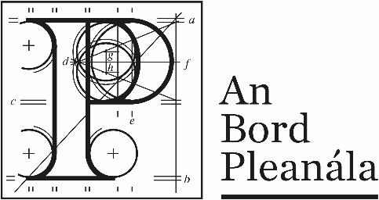 | Memorandum
 | ABP-318220-23
To: | Peter Mullan, Chairperson
From: | Niamh Thornton, Senior Executive Officer
Re: | N6 Galway City Ring Road. Road Application. Co. Galway.
Date: | 29th April 2025

The above referenced Road Application lodged under section 51 of the Roads Act, 1993, as amended is a remitted case (original reference ABP-302808-18).
Furthermore, the associated remitted file ABP-318217-23 (N6 Galway City Ring Road Motorway Scheme 2018 and Protected Road Scheme 2018) is also attached, with a separate Memo.

These files are travelling together and should be dealt with in conjunction with each other.

Following remittal of this case to the Board, and Board Direction dated 10th November 2023, the following steps were taken:
- Further Information was sought from the Applicant, pursuant to section 217B(4) of the Planning and Development Act 2000, as amended, by letter dated 6th December 2023. As per Board Direction a combined request for Further Information issued in relation to this case and associated case ABP-318217-23.
  - Following a number of time extensions the Further Information was received by the Board on 14th April 2025.

- All other participants were notified of the High Court Order and remittal of the case to the Board, and of the request for Further Information issued to the Applicant by letter dated 6th December 2023. As per Board Direction this letter advised that parties would have the opportunity to respond to any Further Information submitted by the Applicant.
  - Parties have not yet been invited to respond to the Further Information submitted by the Applicant.

The Further Information has been placed on the file.

Board Direction:-
The Board to Direct on the following:-

Whether the Board considers any of the Further Information received contains significant additional data relating to:
- the likely effects on the environment of the proposed road development, and
- the likely consequences for proper planning and sustainable development in the area or areas in which it is proposed to situate the said road development.

If the further Information is deemed to be significant, the provisions set out under section 217B(7) of the Planning and Development Act 2000, as amended must be enacted i.e (i) the publication by the applicant of the submission of the Further Information, (ii) invitation of submissions in relation to same and (iii) notification of same to issue to prescribed bodies.

If Further information is not deemed to be significant, it is advised that other parties be invited to respond to the Further Information with the Board to advise on the duration of time to allow for response, as per previous Board Direction.

The Board is also to advise if file should be returned to the Board or Inspectorate to report upon following completion of next steps.

File herewith for Direction.

